

**SOP 4.1 in iCMDB**

**Standard Operating Procedure of Pharmacogenetics Module**

Version 0.1

January 26, 2016

Contents

Summary 2

Introduction and Purpose 4

Responsibilities 4

Specific Procedure 4

Reference 7

Internal and External References 7

External References 7

Change History 7

**Tables**

Table 1 Summary of SOP in Pharmacogenetics (using “CYP2C9” in *Homo sapiens/human* as example) 2

Table 2 Type and description of phenotype 14

Table 3 Strength of Evidences 14

Table 4 Clinical Annotation Levels of Evidence from PharmGKB 14

Table 5 Definition of drug response type 15

Table 6 Standard format for values input and comparison 15

**Figures**

Figure 1 Example of data entry in “Pharmacogenetics Gene” section 6

Figure 2 Example of data entry in “Pharmacogenetics Variant” section 6

Figure 3 Example of data entry in “Population” section 7

Figure 4 Example of data entry in “Drug Gene Rules: Genotype” section 7

Figure 5 Example of data entry in “Drug Gene Rules: Drug-Gene rule” section 8

# Summary

The standard operating of procedure (SOP) of pharmacogenetics module is summarized in Table 1.

Table 1 Summary of SOP in Pharmacogenetics (using “CYP2C9” in *Homo sapiens/human* as example)

|  |  |  |
| --- | --- | --- |
| Name | Description/Format | Examples |
| *Pharmacogenetics Gene* | | |
| Gene* | The gene symbol in Entrez Gene.  The nomenclature follows HGVS standards. | CYP2C9 |
| Accession* | The unique identifier given to a DNA or protein sequence record in a single data repository. | NM_000771 |
| Version* | The sub-version under the same sequence record.  [Number only] | 3 |
| Dosing guideline* | Summarize the guideline that is useful for drug dosing.  Useful resources include Clinical Pharmacogenetics Implementation Consortium (CPIC), Dutch Pharmacogenetics Working Group Guideline (DPWG). | For warfarin dosage, the anticipated stable dose can be estimated using the algorithms available on http://www.warfarindosing.org. For phenytoin, patients with the CYP2C9 poor metabolizer phenotype may require reduced doses and it's also recommended to monitor patients' response and serum concentrations. For phenprocoumon, consider checking INR more frequently in individuals with CYP2C9 2*/2*, 2*/3*, or 3*/3* genotype. |

*Field are required for every entry.

[]: indicate all the possible values in this variable

**Table 1 (continued)**

|  |  |  |
| --- | --- | --- |
| Name | Description/Format | Examples |
| *Pharmacogenetics Variant* | | |
| Category* | The class of genetic changes, including “DELETION”, “INSERTION” and “POINT MUTATION”. Among them, deletion/insertion is the absence/addition of one or more nucleotide base pairs into a DNA sequence, while point mutation is the replacement of single nucleotide. | SNP |
| Chrom* | Chromosome  [1-22, X, Y] | 10 |
| cds mutation syntax* | The syntax on coding DNA sequence.  The nomenclature starts with “c.” and follows HGVS standards. | c.430C>T |
| Amino Acid Substitution | The change of amino acid.  The nomenclature starts with “p.” and follows HGVS standards. | p.R144C |
| Assembly* | The sequence version produced by the Genome Reference Consortium. GRCh37 is preferred in iCMDBTM. | GRCh37 |
| Hg position* | Genomic start position [Number only] | 96702047 |
| Hg position end* | Genomic end position [Number only] | 96702047 |
| Ref seq at pos* | The DNA sequence before the change  [A, C, G, T] | C |
| Alternative seq* | The DNA sequence after the change  [A, C, G, T] | T |
| Ref SNP | A unique ID that was assigned to a submitted SNP record. | rs1799853 |
| Molecular Consequence* | A calculation of the effect of the sequence change | Missense variant |
| Global MAF | The global minor allele frequency calculated by the 1000 Genomes Project | T=0.0479/240 |

*Field are required for every entry.

[]: indicate all the possible values in this variable

**Table 1 (continued)**

|  |  |  |
| --- | --- | --- |
| Name | Description/Format | Examples |
| *Population* |  |  |
| Population Code* | Population abbreviations of 26 populations studied in the 1000 Genomes Project | British in England and Scotland |
| Population Value* | The minor allele frequency in the above population in the 1000 Genomes Project  [Number only] | 0.0879 |
| Source* | Where the population value comes from | 1000 Genome |
| *Drug Gene Rules: Genotype* | | |
| Genotype* | Describe the genotype of individuals using allele 1/allele 2 or genotype (SNP) format. | CYP2C9*1/*2  TT(rs123456) |
| Genetic Variants* | List all genetic variants included for one genotype.  Format should follow the standard nomenclatures of HGVS. | c.430C>T |
| Population Distribution* | Describe the occurrence frequency of allele(s) associated with the genotype in certain populations. | The frequency of alleles CYP2C9*2 vary between 8% and 12% among Caucasians but are lower in Southeast Asians and Africans (Scordo et al., 2002). |
| Reference for population distribution* | Reference ID in iCMDBTM separated by comma. | 7370 |

*Field are required for every entry.

[]: indicate all the possible values in this variable

**Table 1 (continued)**

|  |  |  |
| --- | --- | --- |
| Name | Description/Format | Examples |
| *Drug Gene Rules: Drug-Gene rule* | | |
| Target Drugs* |  | Warfarin |
| Associated Disease/Conditions* | The disease that the mutation will affect.  The disease must be recorded in Disease Module. | cardiovascular diseases, heart disease, primary or revision total hip or knee arthroplasty, atrial fibrillation |
| Reference* | Reference ID in iCMDBTM separated by comma. | 7366,7367,7368,7369,7370,7371 |
| Level of Evidence* | The evidence level follows SOP1.4. | Cohort Study |
| Phenotype* | Drug response/sensitivity | Extensive metabolizer |
| Remarks (Metabolism/PK/PD) * | Describe the phenotype of drug response caused by the variant in two aspects: pharmacokinetics and pharmacodynamics.  Use format like: Compared to wild type, the xxx of variant is xxx. | Compared with CYP2C9*1, the enzyme activity of CYP2C9*2 is only approximately 12%, due to impaired warfarin metabolism and a higher risk of haemorrhage (Özer, 2013; Scordo et al., 2002). |
| Drug Response Type* | Categorize the drug response caused by the variant | Dosage/Toxicity |
| Drug Response Description* | Describe the drug response in details, including the effect, trend, associated diseases. | According to a systematic review that involves 39 studies (7,907 patients), CYP2C9*1/*2 requires warfarin doses that was 19.6% lower than CYP2C9*1/*1 (Lindh et al., 2009). CYP2C9*1/*2 patients also required a 4.79% lower daily maintenance dose than CYP2C9*1/*1 (Özer, 2013). Another study showed that the required daily mean warfarin daily dose is lower in CYP2C9*1/*2 than in CYP2C9*1/*1 (3.56 ± 1.82 vs 4.08 ± 2.13 mg, P = 0.03) (Sconce et al., 2005). For patients with total knee or hip arthroplasty, the therapeutic dose for warfarin could be 17.4% lower per *2 allele (Millican et al., 2007). CYP2C9*2 carriers also have increased risk of bleeding than wild-type (relative risk: 1.9, 95% CI: 1.2–3.2) (Limdi et al., 2008). |

*Field are required for every entry.

[]: indicate all the possible values in this variable

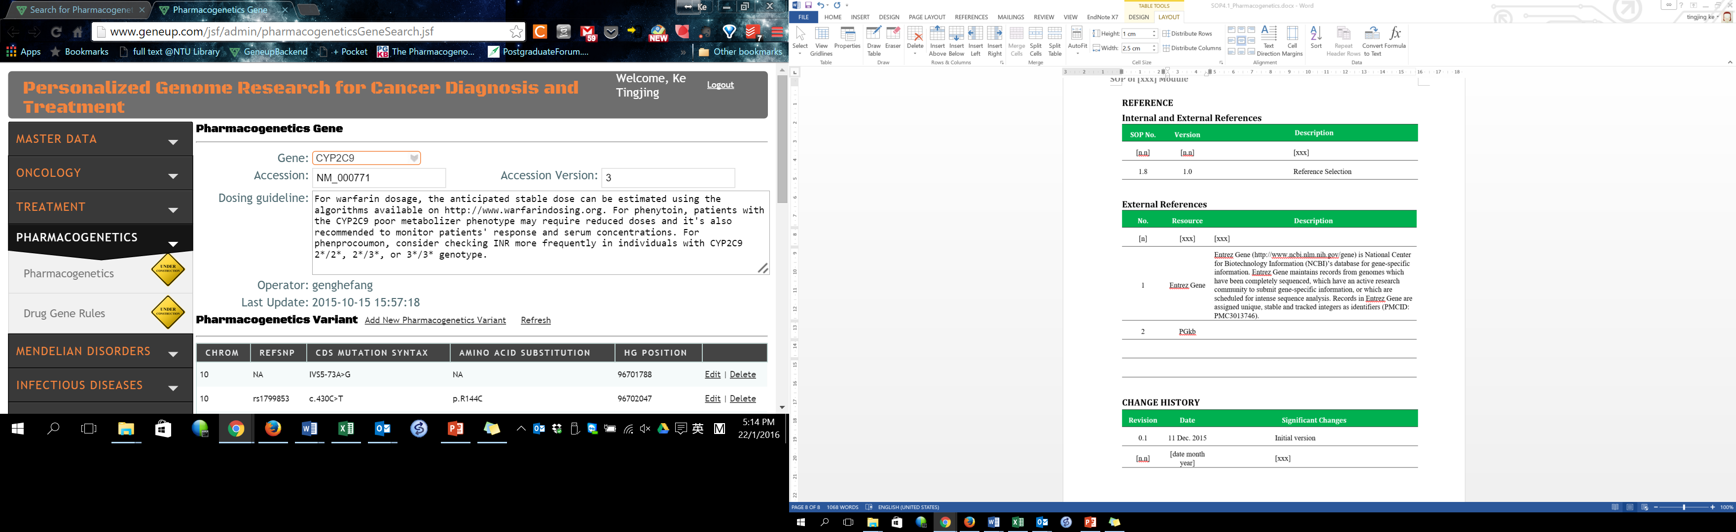

Figure 1 Example of data entry in “Pharmacogenetics Gene” section

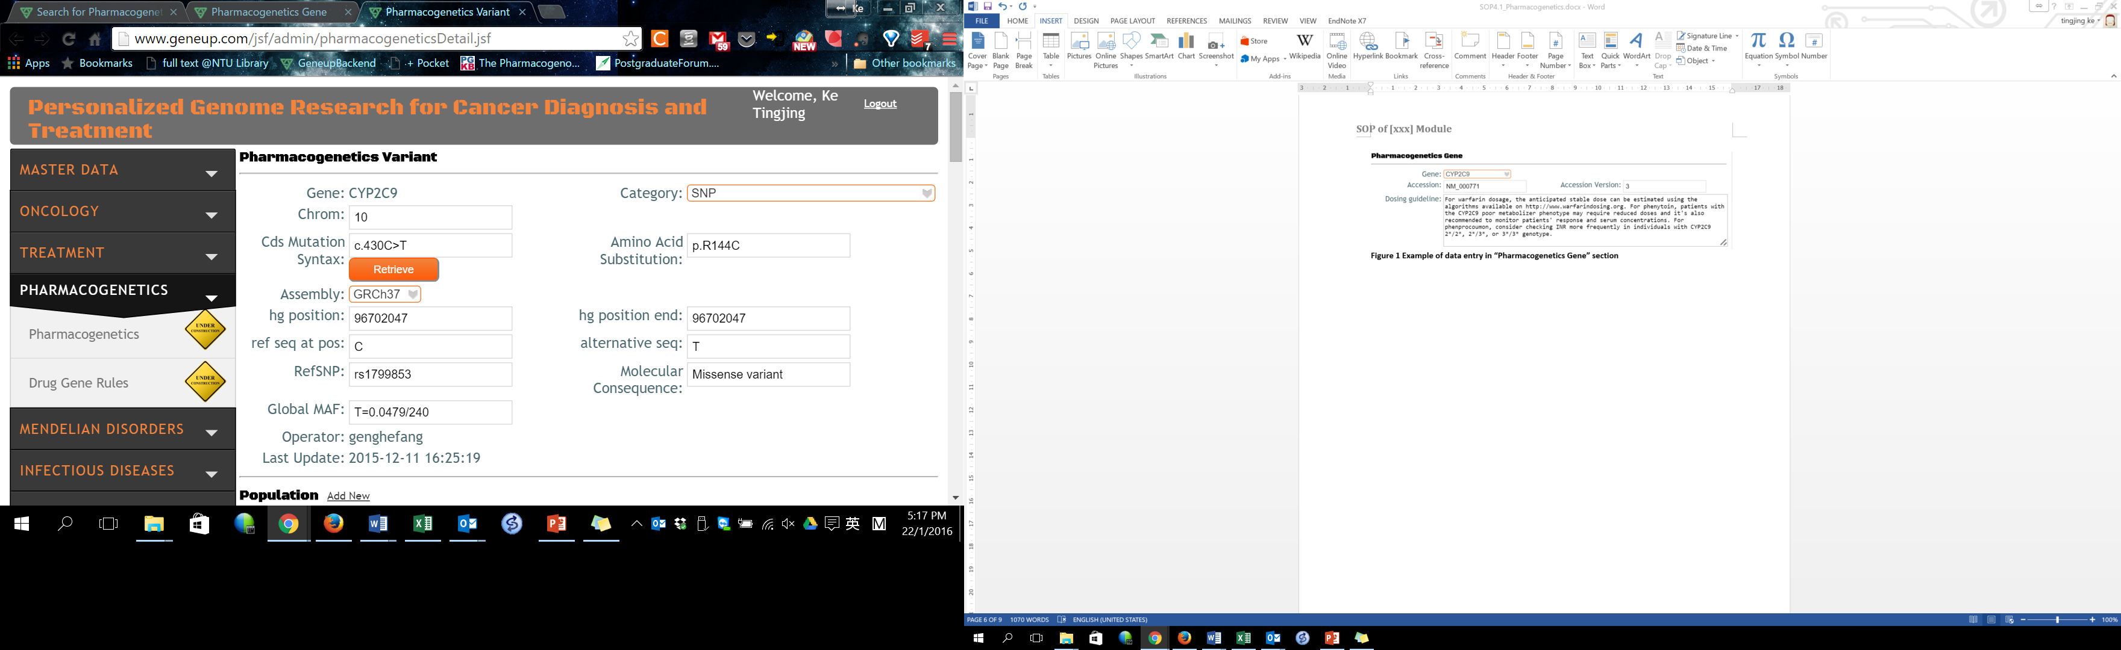

Figure 2 Example of data entry in “Pharmacogenetics Variant” section

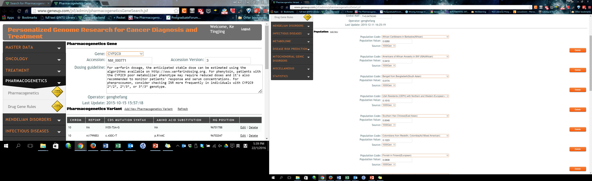

Figure 3 Example of data entry in “Population” section

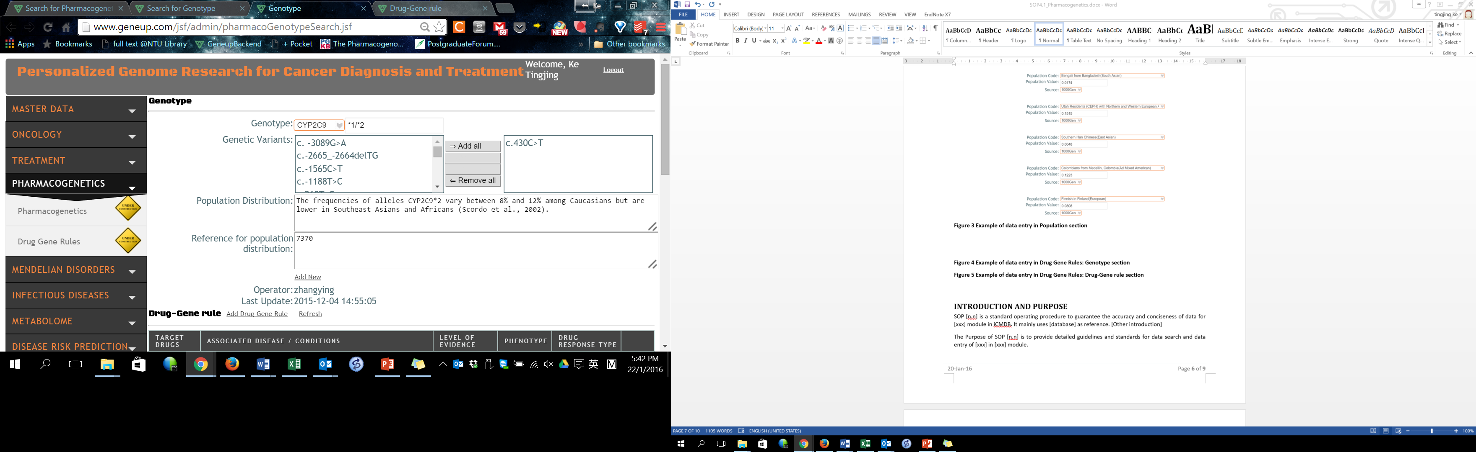

Figure 4 Example of data entry in “Drug Gene Rules: Genotype” section

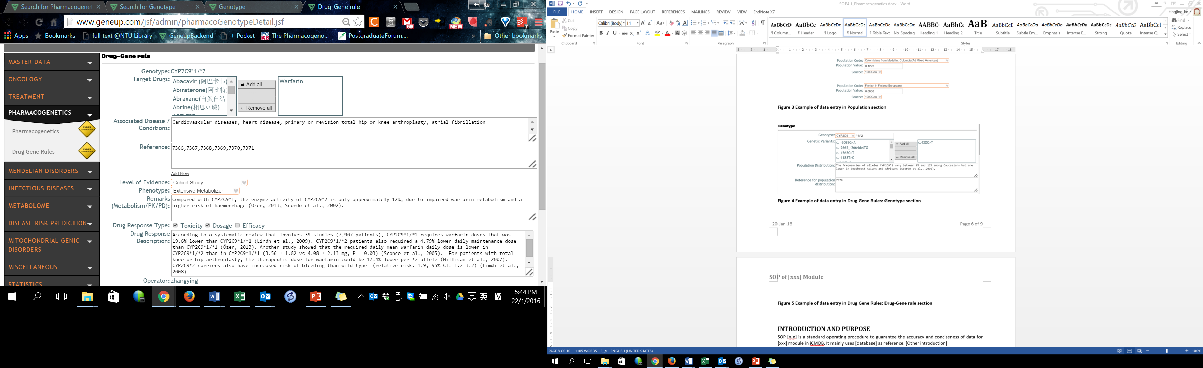

Figure 5 Example of data entry in “Drug Gene Rules: Drug-Gene rule” section

# Introduction and Purpose

SOP 4.1 is a standard operating procedure to guarantee the accuracy and conciseness of data for pharmacogenetics module in iCMDBTM. It mainly uses PharmGKB, Human Cytochrome P450 (CYP) Allele Nomenclature Database, Food and Drug Administration FDA, ClinicalTrials.gov, Human Genome Variation Society (HGVS), Clinical Pharmacogenetics Implementation Consortium (CPIC), Dutch Pharmacogenetics Working Group Guideline (DPWG), The Short Genetic Variations database (dbSNP), Gene, ClinVar, Pubmed, and Drugbank as references.

The Purpose of SOP 4.1 is to provide detailed guidelines and standards for data search and data entry of pharmacogenetics gene and drug gene rules in pharmacogenetics module.

# Responsibilities

Whoever creates the record is responsible for the accuracy of the data in pharmacogenetics module.

# Specific Procedure

**Pharmacogenetics Gene**

1. Go to Pharmacogenetics module in iCMDBTM backend database.
2. Click “Add New” hyperlink near “Search” button in the “Search for Search for Pharmacogenetics Gene” Page.
3. Select the Gene using the official symbol used in NCBI which is found under Summary when you search using Entrez Gene (<http://www.ncbi.nlm.nih.gov/gene>). If the Gene is not present in the database, refer to SOP 1.3 Biomarker Module to add the new gene.
4. Record Accession which is the unique identifier given to the protein sequence record in this case. ***NM_1234***.5 without the last digit which is available in NCBI mRNA and proteins section.

|  |  |
| --- | --- |
|  | Only numbers, alphabets and _ are allowed. |

1. Record accession Version, which is the last value of the Accession NM_1234.***5*.**

|  |  |
| --- | --- |
|  | Only numbers are allowed. |

1. Record dosing guideline. Summarize the dosing guidelines that are relevant for drug dosing of the genotypes which can be located in FDA, Clinical Pharmacogenetics Implementation Consortium (CPIC) and Dutch Pharmacogenetics Working Group Guideline (DPWG), which can be found in the official website (<https://cpicpgx.org/guidelines/>) or PharmGKB when you search for the gene under the “Clinical PGx”. Input the guidelines using the following format,

“For [drug], [gene + phenotype Table 2] patients should consider an alternative drug or a [percentage] reduction/increase of recommended starting dose. In comparison to [drug], [drug] might be associated with increase/decrease [adverse effects] in [gene + phenotype Table 2] patients. Monitor [gene + phenotype Table 2] patient’s response to [drug] and [drug] serum concentration.”

|  |  |
| --- | --- |
|  | If there is no dosing guideline, key in NA. |

**Pharmacogenetics Variant**

1. Click “Add New Pharmacogenetics variant” hyperlink under the Dosing guideline to add new variants.
2. Record the chromosome number where the gene is located. This data is available in Entrez Gene database.

|  |  |
| --- | --- |
|  | Only numbers 1 to 22, X and Y are allowed. Enter the data without any spacing. |

1. Record the category, which is based on the class of genetic changes. This data can be found in NCBI dbSNP which are mostly SNP but could also be point mutation, insertion/deletion and others.
2. Record CDS mutation syntax, which uses the HGVS nomenclature to describe the changes in the coding DNA sequence. This syntax data must be checked to ensure that it aligns with the accession which can be found in NCBI (dbSNP) and PharmGKB. Some Ref SNP is associated with more than one CDS mutation syntax thus we have to key them under a new entry instead. c.963C= represents no change from the reference sequence C.

|  |  |
| --- | --- |
|  | Only c., numbers, A, T, C, G are allowed. Enter the data without any spacing. e.g. NM_000773.3: **c.-1055C>T** |

1. Record amino acid change using one-letter code. The amino acid substitution is the corresponding change of amino acid arising from the CDS mutation syntax sequence following HGVS standards.

|  |  |
| --- | --- |
|  | Only p., numbers, alphabets are allowed. Enter the data without any spacing, e.g. **p.R144C**. If there is no available information, key in NA. |

1. Select the assembly, which is the sequence version produced by the Genome Reference Consortium, the preferred assembly is GRCh37.
2. Record the human genomic position (hg position) which is the genomic start position of the variant based on the GRCh37 assembly.

|  |  |
| --- | --- |
|  | Only numbers are allowed without any spacing, e.g. **96702047** |

1. Record the human genomic position end (hg position end) which is the genomic end position of the variant based on the GRCh37 assembly.

|  |  |
| --- | --- |
|  | Only numbers are allowed without any spacing, e.g. **96702047** |

1. Record Ref seq at pos by clicking on the “Retrieve” button.

|  |  |
| --- | --- |
|  | Check the data especially for “- “strand which should have complementary sequence from cds syntax. Only A, C, G and T are allowed. |

1. Record alternative seq at pos by clicking on the “Retrieve” button.

|  |  |
| --- | --- |
|  | Check the data especially for “- “strand which should have complementary sequence from cds syntax. Only A, C, G and T are allowed. |

1. Record Ref SNP, which is the unique ID assigned to a submitted SNP record which can be found in NCBI (dbSNP) and PharmGKB.

|  |  |
| --- | --- |
|  | If there is no Ref SNP available, key in NA. |

1. Record molecular consequence, which is the calculation of the effect of the sequence change available in NCBI (dbSNP functional consequence).

|  |  |
| --- | --- |
|  | Possible consequences are variant type, stop gain/loss, indel frameshift, splice site donor/acceptor. If there is no molecular consequence available, key in NA. |

1. Record global MAF which is the global minor allele frequency calculated by 1000 genomes project which can be found in NCBI dbSNP and 1000 genomes project using the Ref SNP.

|  |  |
| --- | --- |
|  | Format: [**minor allele=minor allele frequency/sample size**], without spacing in between. If there is no MAF available, key in NA. |

**Population**

1. Click “Add New” beside the Population to add the various population groups studied in the 1000 Genomes Project.
2. Select population code by choosing the corresponding populations as viewed in NCBI dbSNP using the Ref SNP (http://www.ncbi.nlm.nih.gov/variation/tools/1000genomes).
3. Record population value which is the Minor Allele Frequency in the corresponding population code available in NCBI dbSNP in the format:

* [Minor allele frequency value in 4 decimal points]

|  |  |
| --- | --- |
|  | Only numbers are allowed, must be in 4 decimal points e.g. 0.0232. Use the population input method at http://geneup.com/jsf/admin/uploadDetail.jsf to upload MAF values for all variants. |

1. Record source which is where the population value is obtained from in 1000 Genome.

**Drug Gene Rules: Genotype**

1. Go to drug gene rules under the Pharmacogenetics module in iCMDBTM backend database.
2. Click “Add New” under Search for Genotype to input in the details for the genotype.
3. Record Genotype, select the associated gene and input the genotype of individuals using either formats:

* [gene][*[allele]/*[allele] or [gene] [genotype][ref SNP]

|  |  |
| --- | --- |
|  | e.g. CYP2C9*1/*2 (no spacing in between) or CYP2C9 TT(rs1799853) (one spacing between gene name and genotype) |

1. Select the appropriate genetic variants which the genotype is/are linked to and click “🡪 Add “
2. Record the population distribution which describes the frequency of the alleles associated with the genotype. Record this field when the allele consists of more than one cds syntax or when recent specific population study in Southeast Asia are mentioned in papers during research. Be careful to check whether the population study is recent and not outdated.

Use the following format:

* In [x population], [genotype] allele/genotype frequency is [x%] [N=x] [reference]

|  |  |
| --- | --- |
|  | Use **N** when representing numbers of subjects, **vs** when comparing between the values and **P** when indicating p-value. When using **vs**, the sequence must be according to the description respectively, e.g. Chinese lower compared to Caucasian correspondingly Chinese value vs Caucasian value. Genotype format similar to Drug Gene Rules: Genotype No.3. If there is no available information, key in NA. |

1. Record the reference for population distribution, using the reference ID if it has been recorded before in iCMDBTM in the following format:

* [reference ID],[ reference ID],[reference ID] separated by commas without any spaces

|  |  |
| --- | --- |
|  | If the reference is new to the database, refer to SOP 1.4 Reference module to input the reference. If there is no available information, key in NA. |

1. Click “Save” on the bottom of the webpage to ensure that all data inputted is recorded in iCMDBTM.

**Drug Gene Rules: Drug-Gene rule**

1. Click “Add Drug-Gene Rule” under the Genotype to add associated drug interactions that relate to the particular genotype.
2. Select the target drugs that are associated in the study conducted.

|  |  |
| --- | --- |
|  | If the drug is new to the database, refer to SOP 1.2 Drug module to input the drug details. |

1. Record the associated disease/conditions which is the disease that the genotype would affect mentioned in the research paper.
2. Record the reference used in drug-gene rule, using the reference ID if it has been recorded before in iCMDBTM in the following format:

* [reference ID],[ reference ID],[reference ID] separated by commas without any spaces

|  |  |
| --- | --- |
|  | If the reference is new to the database, refer to SOP 1.4 Reference module to input the reference. If there is no available information, key in NA. |

1. Select level of evidence, which is the type of study conducted following the criteria in SOP 1.4 Reference module.

|  |  |
| --- | --- |
|  | Select the highest level of evidence if there are more than one reference mentioned in the description. |

1. Select strength of evidence, following the criteria in Table 3 based on the remarks or drug response description.

|  |  |
| --- | --- |
|  | Select the highest strength of evidence if there are more than one reference mentioned in the description. |

1. Select clinical annotation levels of evidence following the criteria in Table 4 which is indicated under “Clinical PGx” in PharmGKB.

|  |  |
| --- | --- |
|  | Select the highest clinical annotation levels of evidence if there are more than one reference mentioned in the description. If there is no available information, key in NA. |

1. Select superpopulation which represents the race of the subjects in the study. If there are more than one, select the relevant superpopulations.

|  |  |
| --- | --- |
|  | Possible options are African, American, East Asian, European and South Asian. If there is no available information, key in NA. |

1. Record the population ethnic group (sub-population) which represents the ethnic group of the subjects in the study. If there are more than one, select the relevant ethnic groups.

|  |  |
| --- | --- |
|  | If there is no available information, key in NA. |

1. Select phenotype based on the CPIC or DPWG guidelines available or based on the phenotype mentioned in the research paper. If there is no information mentioned above, use Table 2 to identify the suitable phenotype.

|  |  |
| --- | --- |
|  | If there is no available information, key in NA. |

1. Record remarks (Metabolism/PK/PD). When comparing between subjects, use the genotype when describing. Combine all the information on Metabolism/PK/PD mentioned in different papers into the remarks, mention the key points first followed by additional details. Be careful the determination of wild type which is not always same as the reference sequence. To determine wild type genotype, we would have to check the global MAF of the variant or refer to the research paper to see if the wild type of the variant is mentioned.

Use the following format examples to describe the remarks:

* Compared with wild type [genotype], [genotype] had decreased/increased metabolism of [Drug] in [subjects] [N=x vs N=x, x% vs x%, P=x] [reference]
* Compared with wild type [genotype], [genotype] had decreased/increased elimination of [Drug], with higher/lower AUC/intrinsic clearance in [subjects] [N=x vs N=x, value vs value, P=x]
* Compared with wild type [genotype], [genotype] had decreased/increased expression levels of [gene] when assayed with [experiment] in [subjects] [N=x, value vs value, P=x] [reference]
* Compared with wild type [genotype], [genotype] had decreased/increased [gene] enzyme activity when assayed with [experiment] in [subjects] [N=x, value vs value, P=x] [reference]

|  |  |
| --- | --- |
|  | Use **N** when representing numbers of subjects, **vs** when comparing between the values and **P** when indicating p-value. When using **vs**, the sequence must be according to the description respectively, e.g. *1/*1 lower activity compared to *1/*2, (*1/*1 value vs *1/*2 value). Other symbols such as **CI**, **X^2**, **10^x,** **±** and **OR** should have the standard symbol using the uppercase or lowercase accordingly. Use comma and space to separate the different components, e.g. **(N=23, OR=5.5, 95% CI: 1.6–19.8, 3.7 ± 1.3 vs 13.7 ± 5.8ml/mg, 4.2 pmol /10^7 RBC/h, X^2=3, P=0.001).** |

1. Select drug response type following the criteria in Table 5, tick the necessary boxes if there are more than one response type.
2. Record drug response description, which describes the drug response including the genotypes, effect, trend and associated diseases found in the research paper/PharmGKB. Combine all the information on drug response mentioned in different papers into the description, mention the key points first followed by additional details. Use the following format examples for the descriptions:

* **Efficacy**: Compared with wild type [genotype], [genotype] had increased/decreased response to [drug], with increased/decreased [associated disease/conditions] in [subjects] [N=x, values, OR= x, 95% CI: x-x, P=x] [reference]
* **Toxicity**: Compared with wild type [genotype], [genotype] had increased/decreased risk of [associated disease/conditions] when treated with [drug] in [subjects] [N=x, OR: x, 95% CI: x-x, P=x] [reference]

**Dosage**: Compared with wild type [genotype], [genotype] had increased/decreased [drug] dose requirements in [subjects] [N=x vs N=x, values vs value, x% vs x%, P=x] [reference]

* **Others:** A [disease] patient with [genotype] had increased/decreased [adverse effects] after treatment with [drug][amount][reference]

**For annotations that are too long under a single segment, we have to summarize accordingly. May need to leave out more details.**

|  |  |
| --- | --- |
|  | Use **N** when representing numbers of subjects, **vs** when comparing between the values and **P** when indicating p-value. When using **vs**, the sequence must be according to the description respectively, e.g. Chinese lower compared to Caucasian correspondingly Chinese value vs Caucasian value. Other symbols such as **CI**, **X^2**, **10^x,** **±** and **OR** should have the standard symbol using the uppercase or lowercase accordingly. Use comma and space to separate the different components, e.g. **(N=23, OR=5.5, 95% CI: 1.6–19.8, 3.7 ± 1.3 vs 13.7 ± 5.8ml/mg, 4.2 pmol /10^7 RBC/h, X^2=3, P=0.001).** |

1. Click “Save” on the bottom of the webpage to ensure that all data inputted is recorded in iCMDBTM.

Table 2 Type and description of phenotype

|  |  |
| --- | --- |
| Phenotype | Description |
| Ultrarapid metabolizer | More than two copies of functional alleles |
| Extensive metabolizer | Two functional alleles; or two reduced function alleles; or one functional allele and one reduced or non-functional allele |
| Intermediate metabolizer | One reduced functional allele and one non-functional allele |
| Poor metabolizer | Two non-functional alleles |

Table 3 Strength of Evidences

|  |  |
| --- | --- |
| Strength | Description |
| 1 | Meta-analysis or systematic review of genotype-drug rules or genotype-drug rules in CPIC/DPWG guideline or FDA |
| 2+ | Genotype-drug rule that has been repeatedly reported with strong effect on dosage, efficacy or life-threatening toxicity or organ injury related toxicity |
| 2- | Genotype-drug rule that has been repeatedly reported with moderate or small effect on dosage, efficacy or the risk of developing diseases |
| 3 | Genotype-drug rule effects reported in single study |
| 4 | Case report and in-vitro studies |

Table 4 Clinical Annotation Levels of Evidence from PharmGKB

|  |  |
| --- | --- |
| Level | Description |
| 1A | Annotation for a variant-drug combination in a CPIC or medical society-endorsed PGx guideline, or implemented at a PGRN site or in another major health system. |
| 1B | Annotation for a variant-drug combination where the preponderance of evidence shows an association. The association must be replicated in more than one cohort with significant p-values, and preferably will have a strong effect size. |
| 2A | Annotation for a variant-drug combination that qualifies for level 2B where the variant is within a VIP (Very Important Pharmacogene) as defined by PharmGKB. The variants in level 2A are in known pharmacogenes, so functional significance is more likely. |
| 2B | Annotation for a variant-drug combination with moderate evidence of an association. The association must be replicated but there may be some studies that do not show statistical significance, and/or the effect size may be small. |
| 3 | Annotation for a variant-drug combination based on a single significant (not yet replicated) or annotation for a variant-drug combination evaluated in multiple studies but lacking clear evidence of an association. |
| 4 | Annotation based on a case report, non-significant study or in vitro, molecular or functional assay evidence only. |

**Standard format for dosing guideline**

|  |  |
| --- | --- |
| Scenario | Examples of standard format |
| CPIC dosing guideline summary obtained | For [drug], [gene phenotype] patients should consider an alternative drug or a [percentage] reduction/increase of recommended starting dose. In comparison to [drug], [drug] might be associated with increase/decrease [adverse effects] in [gene phenotype] patients. Monitor [gene phenotype] patient’s response to [drug] and [drug] serum concentration. |

Table 5 Definition of drug response type

|  |  |
| --- | --- |
| Drug Response Type | Description |
| Toxicity | In individuals with a certain genotype, a certain drug will induce adverse reactions or toxicity |
| Dosage | In individuals with a certain genotype, an increased/decreased dose is required to achieve certain effects |
| Efficacy | In individuals with a certain genotype, the efficacy of a certain drug is altered. |
| N.A | Not applicable as the variation has no effect on drug response at the time of data curation. |

Table 6 Standard format for values input and comparison

|  |  |  |
| --- | --- | --- |
| Values | Standard Format to follow | Examples |
| Number of subjects | N=x, to represent x out of x use N=x/x , N is in the uppercase | In [population], [genotype] allele frequency is 0.68% (N=100).  Compared with wild type [genotype], [genotype] had increased risk of toxicity [N=6/36 vs 2/2]. |
| p-value | P=x or P<x, P is in uppercase | Compared with wild type [genotype], [genotype] have lower intrinsic clearance (N=x, OR=x, 95% CI: x-x, P<x) (reference)  *Use English comma followed by space to separate the different values (x, x, x) as shown in the examples. |
| Odds ratio | OR=x |
| Confidence interval | 95% CI: x-x |
| To the power of | 10^x, m^-2, x^2 | Compared with wild type [genotype], [genotype] have lower intrinsic clearance (N=x vs x, x ± x vs x ± x mL/10^7 RBC, P<x) (reference)  *When using **vs** or **and**, the sequence must be according to the description respectively in this case is wild type **vs** variant genotype. |
| Standard error | x ± x |
| Comparing values or more than one values | vs, and |
| SI units | %, pmol, mg, mL, RBC, h and etc. | Use the appropriate SI units mentioned in the research paper accordingly, following the correct uppercase or lowercase. |

Table 7 Standard format for remarks (Metabolism/PK/PD).

|  |  |
| --- | --- |
| Scenario | Examples of standard format |
| Variant genotype has different metabolism | Compared with wild type [genotype], [genotype] had decreased/increased metabolism of [drug] in [subjects] [N=x vs N=x, x% vs x%, P=x] [reference] |
| Variant genotype has different AUC/intrinsic clearance | Compared with wild type [genotype], [genotype] had decreased/increased elimination of [drug], with higher/lower [AUC/intrinsic clearance] in [subjects] [N=x vs x, value vs value, P=x] |
| Variant genotype has different expression level of the gene it encodes | Compared with wild type [genotype], [genotype] had decreased/increased expression levels of [gene] when assayed with [experiment] in [subjects] [N=x, value vs value, P=x] [reference] |
| Variant genotype has different enzyme activity | Compared with wild type [genotype], [genotype] had decreased/increased [gene] activity when assayed with [experiment] in [subjects] [N=x, value vs value, P=x] [reference] |

Table 8 Standard format for drug response description

|  |  |
| --- | --- |
| Scenario | Examples of standard format |
| Efficacy | Compared with wild type [genotype], [genotype] had increased/decreased response to [drug] or increased/decreased [progression free survival, event free survival] in [subjects] [N=x, values, OR= x, 95% CI: x-x, P=x] [reference]. |
| Toxicity | Compared with wild type [genotype], [genotype] had increased/decreased risk of [associated disease/conditions/adverse effects] when treated with [drug] in [subjects] [N=x, OR: x, 95% CI: x-x, P=x] [reference] |
| Dosage | Compared with wild type [genotype], [genotype] had increased/decreased [drug] dose requirements in [subjects] [N=x vs x, values vs value, x% vs x%, P=x] [reference] |
| Others | Compared with wild type [genotype], [genotype] had increased [tolerance/discontinuation] of drug in [subjects] [N=x vs x, values vs value, x% vs x%, P=x] [reference]  A [disease] patient with [genotype] had increased/decreased [adverse effects] after treatment with [drug][amount][reference] |

# Reference

## Internal and External References

|  |  |  |  |
| --- | --- | --- | --- |
| SOP No. | Version | Description | |
| 1.1 | 1.0 |  | SOP for Disease |
| 1.2 | 1.0 |  | SOP for Drug |
| 1.3 | 1.0 |  | SOP for Biomarker |
| 1.4 | 1.0 |  | SOP for Reference |
| 1.8 | 1.0 |  | Reference Selection |

## External References

|  |  |  |
| --- | --- | --- |
| No. | Resource | Description |
|  |  |  |
| 1 | Entrez Gene | Entrez Gene (http://www.ncbi.nlm.nih.gov/gene) is National Center for Biotechnology Information (NCBI)’s database for gene-specific information. Entrez Gene maintains records from genomes which have been completely sequenced, which have an active research community to submit gene-specific information, or which are scheduled for intense sequence analysis. Records in Entrez Gene are assigned unique, stable and tracked integers as identifiers (PMCID: PMC3013746). |
| 2 | PharmGKB | PharmGKB (<https://www.pharmgkb.org>) is a pharmacogenomics knowledge resource that encompasses clinical information including dosing guidelines and drug labels, potentially clinically actionable gene-drug associations and genotype-phenotype relationships. |
| 3 | dbSNP | dbSNP (<http://www.ncbi.nlm.nih.gov/snp/>) is a public-domain archive for a broad collection of simple genetic polymorphisms in National Center for Biotechnology Information (NCBI). dbSNP was designed to support submissions and research into a broad range of biological problems including physical mapping, functional analysis, pharmacogenomics, association studies and evolutionary studies. |
| 4 | 1000 Genomes | 1000 Genomes (http://browser.1000genomes.org/index.html) is the first project to sequence the genomes of a large number of people in order to provide a comprehensive resource on human genetic variation. Data from the 1000 Genomes Project is a freely accessible public database of most genetics variants that have frequencies of at least 1% in the populations studied. |
| 5 | Drugbank | Drugbank (http://www.drugbank.ca) database is a unique bioinformatics and cheminformatics resource combining detailed drug data with comprehensive drug target information in National Center for Biotechnology Information (NCBI). |
| 6 | ClinVar | ClinVar (<http://www.ncbi.nlm.nih.gov/clinvar/>) is a freely accessible public archive of reports containing relationships among human variations and phenotypes with supporting evidence. |
| 7 | PubMed | Pubmed (<http://www.ncbi.nlm.nih.gov/pubmed/>) is a database for biomedical literature from MEDLINE. Life science journals and online books in National Center for Biotechnology Information (NCBI). |
| 8 | Clinical Pharmacogenetics Implementation Consortium (CPIC) | The Clinical Pharmacogenetics Implementation Consortium (CPIC, https://cpicpgx.org/guidelines/) was formed as a shared project between PharmGKB and the Pharmacogenomics Research Network. CPIC guidelines are peer-reviewed and published in a leading journal (in partnership with Clinical Pharmacology and Therapeutics) with simultaneous posting to PharmGKB with supplemental information/data and updates. CPIC's goal is to address some of the barriers to implementation of pharmacogenetic tests into clinical practice. |
| 9 | Dutch Pharmacogenetics Working Group Guideline (DPWG) | The Dutch Pharmacogenetics Working Group (DPWG, https://www.pharmgkb.org/page/dpwg) is established in 2005 by the Royal Dutch Pharmacist's Association (KNMP). The DPWG is multidisciplinary and includes clinical pharmacists, physicians, clinical pharmacologists, clinical chemists, epidemiologists, and toxicologists. Objectives of the DPWG are to develop pharmacogenetics-based therapeutic (dose) recommendations and assist drug prescribers and pharmacists by integrating the recommendations into computerized systems for drug prescription and automated medication surveillance. |
| 10 | Human Cytochrome P450 (CYP) Allele Nomenclature Database | The main purpose of the Human Cytochrome P450 (CYP) Allele Nomenclature (http://www.cypalleles.ki.se/criteria.htm) is the management of an official and unified allele designation system, as well as the provision of a database of CYP alleles and their associated effects. |
| 11 | Food and Drug Administration (FDA) | Food and Drug Administration (FDA, http://www.fda.gov/) is a federal agency of U.S. It is responsible for protecting the public health by assuring the safety, efficacy and security of human and veterinary drugs, biological products, medical devices, our nation’s food supply, cosmetics, and products that emit radiation. This website updates all related information released by U.S government. |
| 12 | ClinicalTrials.gov | ClinicalTrials.gov (https://www.clinicaltrials.gov/) is a registry and results database of publicly and privately supported clinical studies of human participants conducted around the world. |
| 13 | Human Genome Variation Society (HGVS) | Human Genome Variation Society (HGVS, http://www.hgvs.org/) aims to foster discovery and characterization of genomic variations including population distribution and phenotypic associations. HGVS promotes collection, documentation and free distribution of genomic variation information and associated clinical variations and endeavor to foster the development of the necessary methodology and informatics. |

# Change History

|  |  |  |  |
| --- | --- | --- | --- |
| Revision | Date | Significant Changes | |
| 0.1 | 26-Jan-16 |  | Initial version |
| [n.n] | [date month year] |  | [xxx] |